7.2.1 - Two best practices successfully implemented by the Institution as per NAAC format provided in the Manual.
Best Practices I
Title of the practice: Environmental conservational programs

Objectives of the practice:
- To create awareness about sustainable development and environmental conservation.
- Involve students towards plantation and other environmental conservational activities.
- Tomake students understand the importance of clean and green atmosphere.
- To keep the college and surroundings free from pollution.
- To make the college campus clean and green.
The Context:
Environmental pollution is a big problem faced by today’s world. Creating awareness about environmental issues among students and involving them in to environmental conservational activities is certainly a good practice towards combating environmental challenges.
The Practice: Different environmental conservational activities are being organized by various departments of the college. Department of chemistry celebrate Plastic Bag Free day in the month of July (since International Plastic Bag Free day is celebrated on 3rd July) every year. In this program various activities are organized to make the students aware about bad effects of plastic on our environment.
Department of Botany organizes ‘Green Day’ every year in the month of July/August to make college community understand the importance of plant in our lives. Under this program plantation is done along with several other activities.
College has MOU with green army which is an NGO for creating awareness and involving student in environmental promotional activities.
From Red Cross and NSS wing also environmental conservational activities and plantation is being done.
Evidence of success:
I. Two days National Seminar on “Environmental conservation and sustainable development “ : On 16-17 January 2018 Chhattisgarh Council of Scientific Research (CGCOST) sponsored seminar was organized, where 80 abstract from various research fraternity have been submitted. During the seminar 40 papers were presented.
II. Celebration of Plastic Bag Free Day
- Session 2018-19: Celebrated on 28 July 2018 under which Essay writing, Slogan/poster and Speech competition were held to create awareness about harmful effect of plastic on environment.
- Session 2019-20: Celebrated on 14 Aug 2019 under which Essay writing, Slogan/poster and Speech competition were held to create awareness about harmful effect of plastic on environment.
- Session 2020-21: Celebrated on 13 July 2020. Being an unusual epidemic year e- Slogan/poster and Online Speech competition were held to create awareness about harmful effect of plastic on environment.
- Session 2021-22: Celebrated on 13 July 2021. Online Talk by Mr. Amitabh Dubey, President Green Army, C.G.and Poster/ slogan competition.
- Session 2022-23: Celebrated on 15July 2022. Online guest lecture by Mr. Naveen Malviya, Scientist, Chhattisgarh Environment Conservation Board, and Poster/slogan competition.

III. Celebration of “ Go-Green Day”:
- Session 2018-19: Celebrated on 04-08-2018 under which Slogan/poster making, plantation, Go Green rally was organised.
- Session 2019-20: Celebrated on 10-08-2019 under which Slogan/poster making, plantation activity and Go Green rally was organised.
- Session 2020-21: Online poster slogan making on the importance of plant in our lives.
- Session 2022-22: Celebrated on 02-07-2021 under which Slogan/poster making, plantation activity and Go Green rally was organised.
IV. Plantation activities: During monsoon season plantation activity inside and outside the campus is done on regular basis by students, faculties and alumni.
V. Collaborative program with Chhattisgarh Environmental Conservation board on Environmental awareness:
Two Program has been conducted under this approach:
- ‘Single use plastic ka Vilopan Abhiyan’ on 5.10.2021: In this programme a team from CECB has conducted poster, speech and slogan making competition with the students of our college.

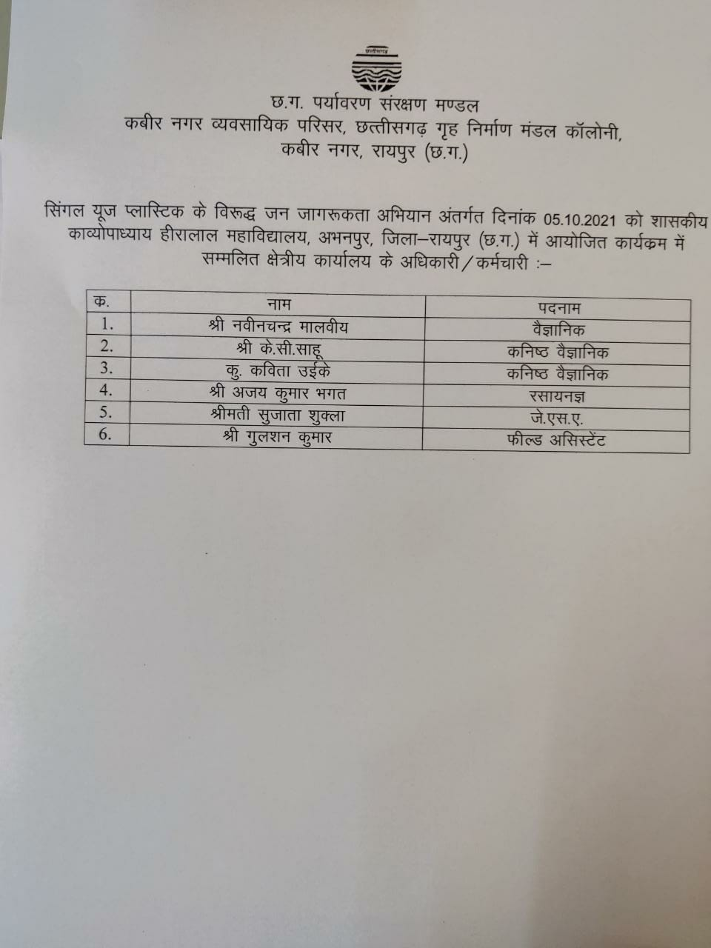

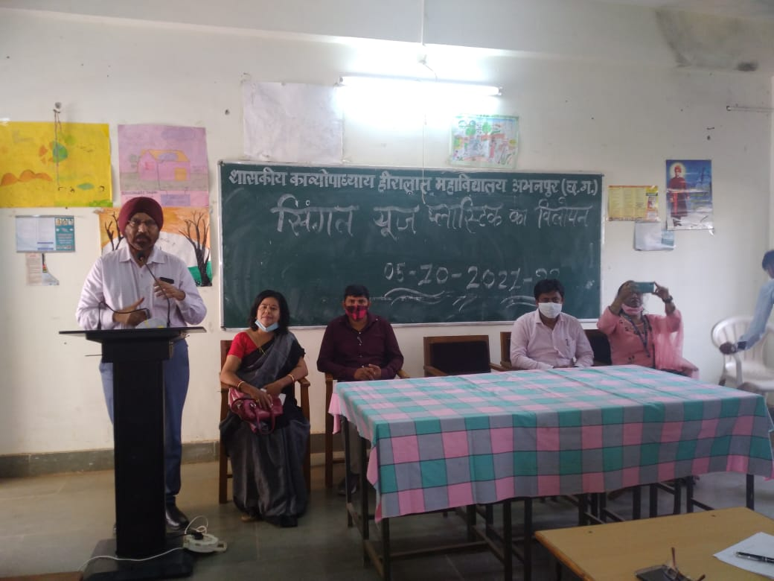

- Celebration of ‘World Earth Day’ on 22 April 2024: The theme of the program was Planet verses Plastic. In this program quiz competition has been organised for the students for creating the awareness for the Environment.

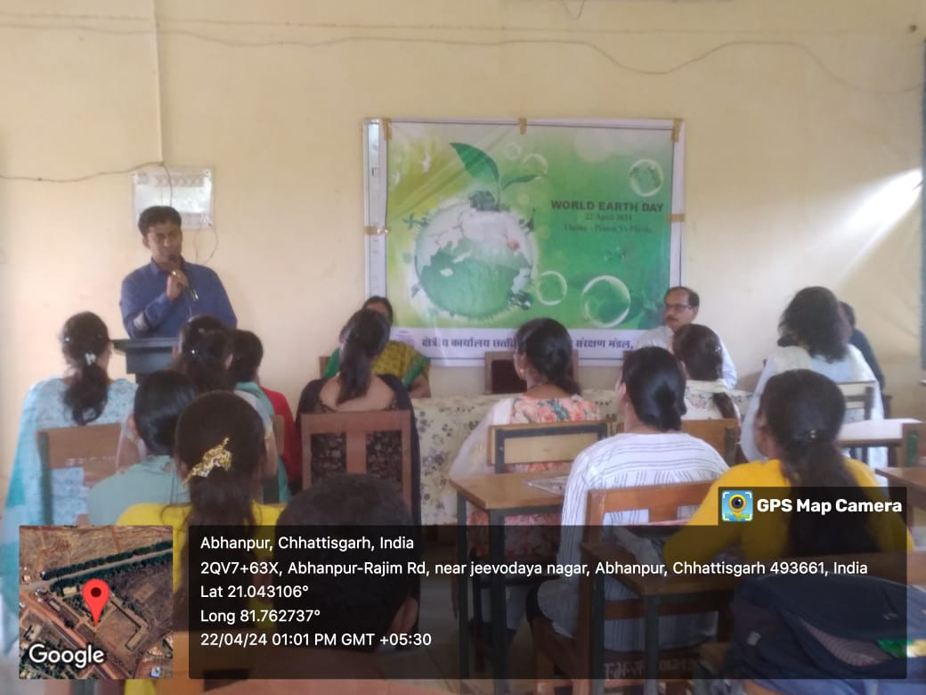

Problem encountered and resource required:
- Hesitation and lack of interest among students in taking part in such programs.
Strong motivation is required.
- Proper care of new plants is required. Scarcity of man power
makes it difficult.
- Some of the students/ NCC cadets have been assigned duties of
taking care of plants but during vacations and exams it becomes difficult when they do not turn up to the college.
- It become difficult for the overburdened staff to arrange such
activities since for maximum subject there is single teaching staff available.

Glimpse of success

Plantation Programme
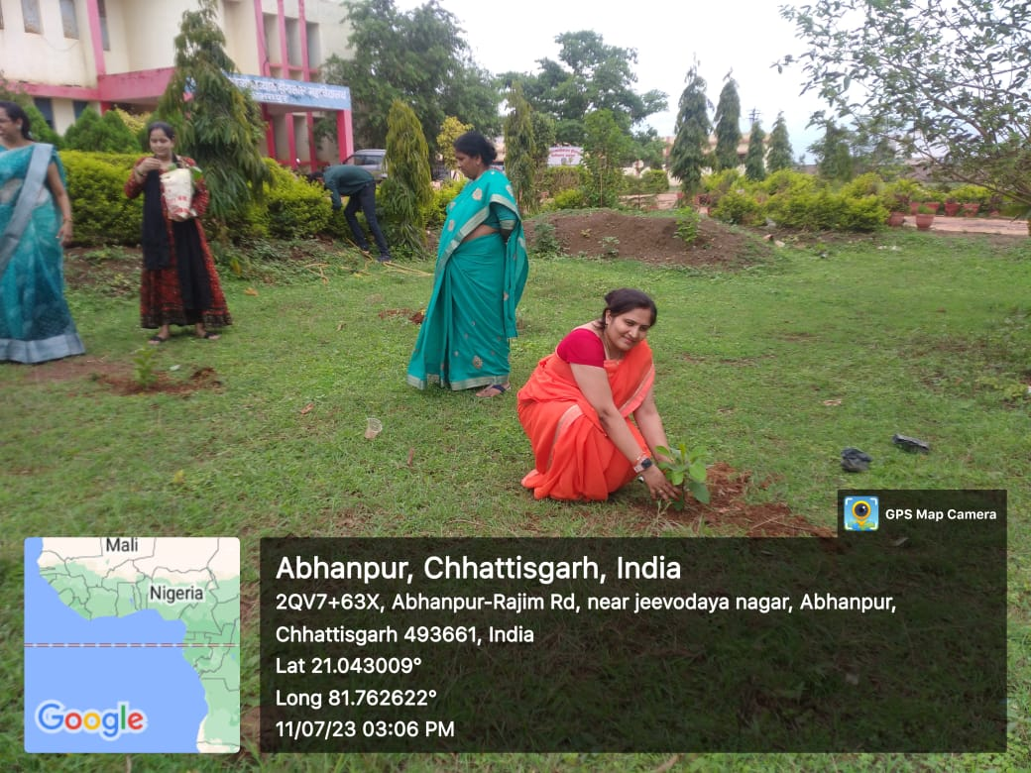
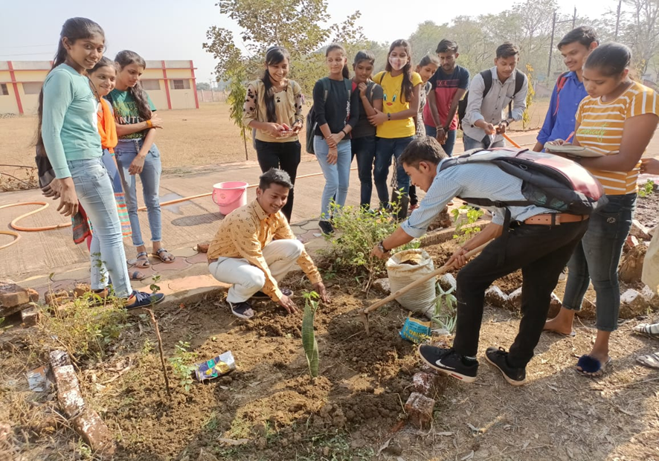

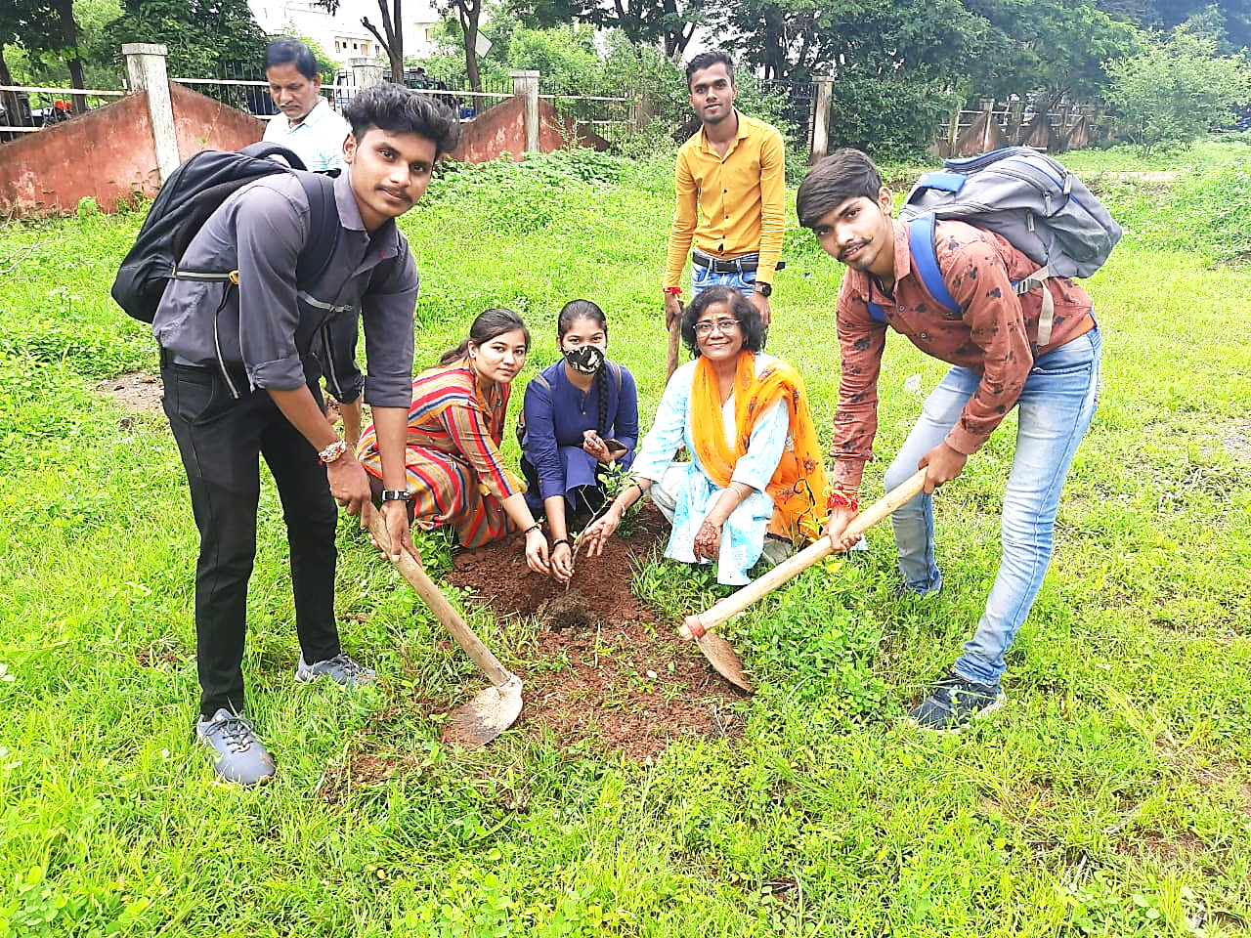
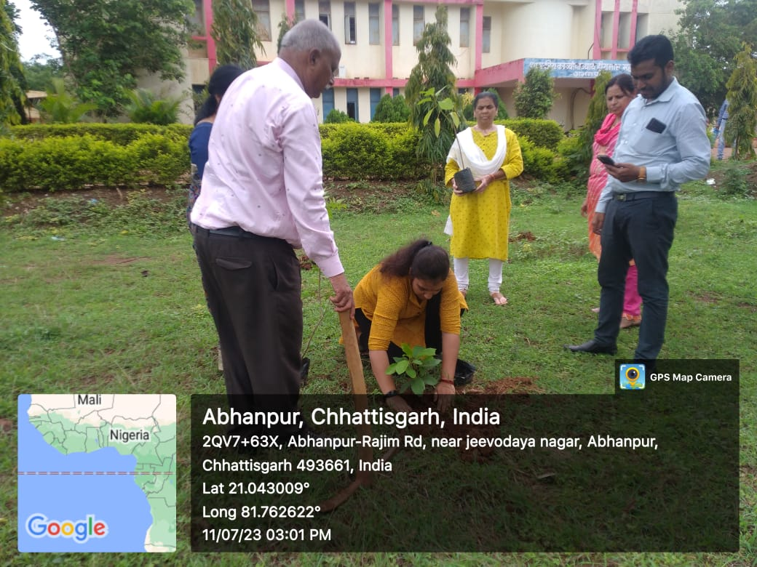

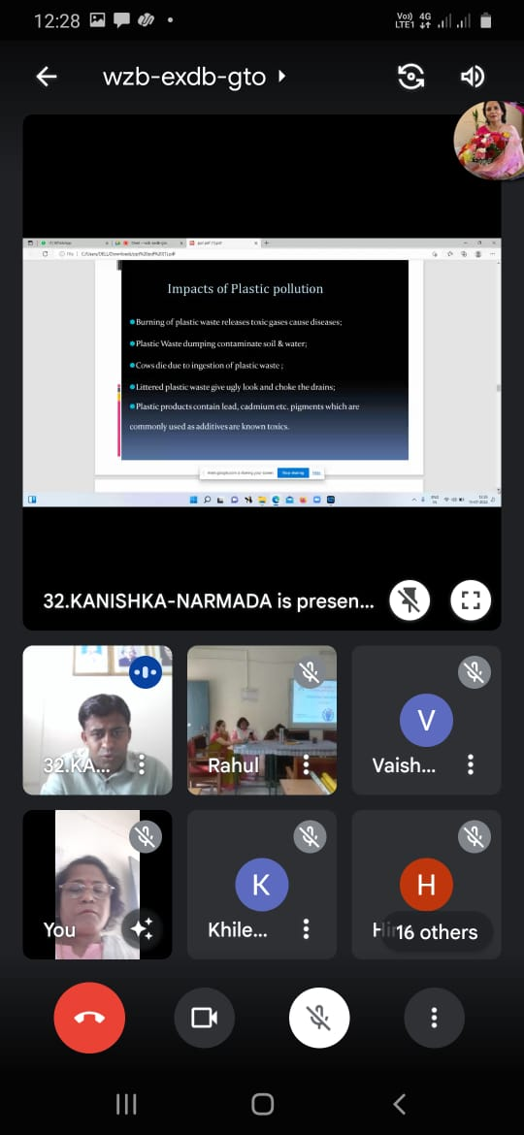
Online Guest lecture by Dr. Navin Chandra Malviya, Scientist, C.G. Environmental Conservation Board, Raipur

Poster Presentation on No plastic Bag Day

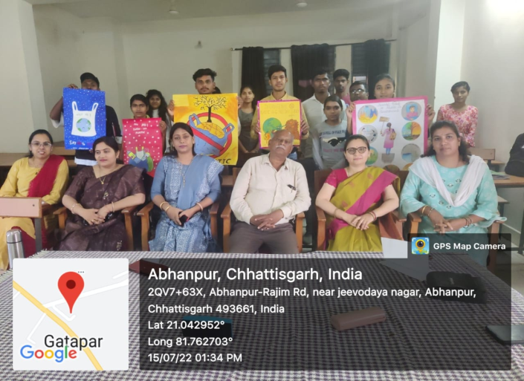
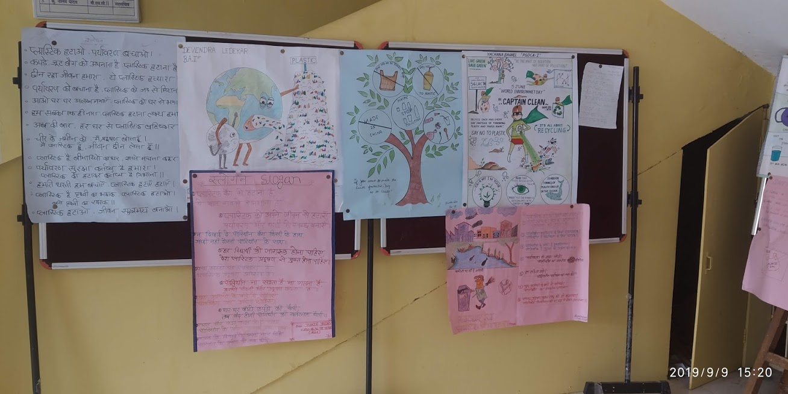
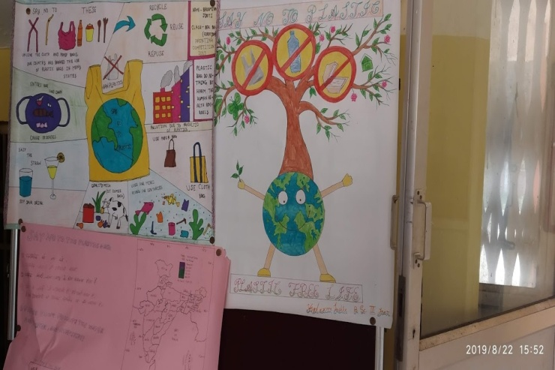
Speech competition on no platic bag day
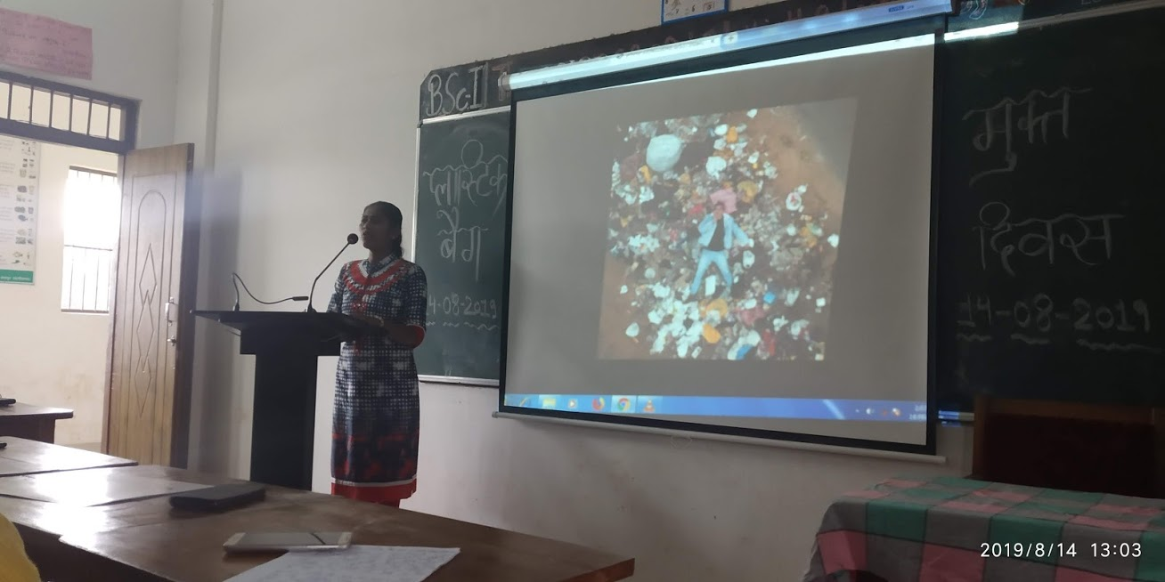

Best Practices II
Title of the practice: Organization of health camps and health promotional activities
Objectives of the practice:Following are the objectives of this practice:
- Organize different type of health checkup camps
- Organize blood donation camps to serve the need of healthy blood for the community.
- Create healthy human resource for the society.
- Create awareness about importance of good health among students

The context: Govt. K. H. College, Abhanpur, being placed in rural area has maximum students from different villages in its surrounding area. The plight of health services is not up to the mark in this area. Secondly most of the students are from financially weaker sections which are busy with earning their livelihood thus ignoring the importance of good health in life. The college is playing its guardianship to such students in terms of organizing such health checkup and health promotional activities.
Abhanpur area covers students from certain community where sickle cell anemia is a very common problem which affects the health of present as well as the future generations. Organization of sickle cell checkup camp is beneficial in overcoming this problem.
The Practice: Different kinds of health camps are being organized in the institute under the collaboration of IQAC, Youth Red Cross Society and NSS wing of the college. The practice involves organization of Sickle cell checkup camp, Blood Donation camp, Eye checkup camp, general health checkup camp, vaccination camp etc. NSS wings organise various health awareness camps in the neighboring community during NSS camps.
In addition to this awareness about health related issues is generated by organizing programs like guest lectures, speech, poster and slogan making etc.
Evidence of success:
Details of various camps organized in the college
- Eye checkup camp session 2017-18
- Sickle cell checkup camp on 14.12.18 (session 2018-19) : 202 students were tested for sickeling
- Blood Donation Camp on 14.11.19 (session 2019-20): 44 students took part out of which 39 were eligible for blood donation
- No camp has been organized due to Covid-19 pandemic in session 2020-21
- Vaccination camp on 3.06.21, 7.01.2022 and 8.01. 2022 (session 2021-22): Near about 200 students were vaccinated by Covishield and co-vaccine.
- Health checkup Camp on 13.11.21(session 2021-22): 162 students including college staff members were undergone general health checkup
- Sickle cell screening camp on 16.11.22 (session 2022-23)
- Health checkup Camp on 02.12.22 (session 2022-23)
- Eye checkup camp on 12.10.23 (session 2023-24)
- Sanitary pad distribution on 25.11.23 (session 2023-24)
- Sickle cell, HIV and Syphilis and general health check-up organized in the college premise for the students and staffs on 16.12.2024.

Details of various health awareness activities organized :
- Poster, slogan making on AIDS awareness on 1-12-2020
- Speech competition on AIDS awareness on 12-01-2021
- Poshan Pakhwada from 4.04.21 to 9.04.21
- Lecture on Tobacco control on 18.04.2021 & 19.04.2021
- Webinar on “Impact of pandemic Covid 19 on mental health and importance of vaccination” by the doctors of Dr. Bhimrao Ambedkar Memorial Hospital, Raipur on 08-06-2021
- Mask distribution camp on 07-08-2021
- Lecture on Eye Issues by Dr. Vikas Mishra on 27-09-2021
- Speech competition on ‘World Heart Day’ on 29.09.2021
- Poster and slogan making competition and formation of Human Chain on ‘World AIDS Day’ on 01.12.2021
- HIV/AIDS awareness rally on 25.08.22
- Lecture on Heart Health by Dr. Animesh Choudhary on ‘World Heart Day’ (29.09.2022).
Problem encountered and resources required:
- Hesitation and fear among students in taking part in such heath check-up camp.
- Social enigma among students especially in case of sickle cell, if tested positive which may create problems in setting their marriages.
- Fear of losing health after blood donation.
- Some students do not want to go through pain full experience.
- It is difficult for the overburdened staff to arrange such activity.
- Financial constrains.

Glimpse of success

